Query -01:
This gives a unique rank within each category.

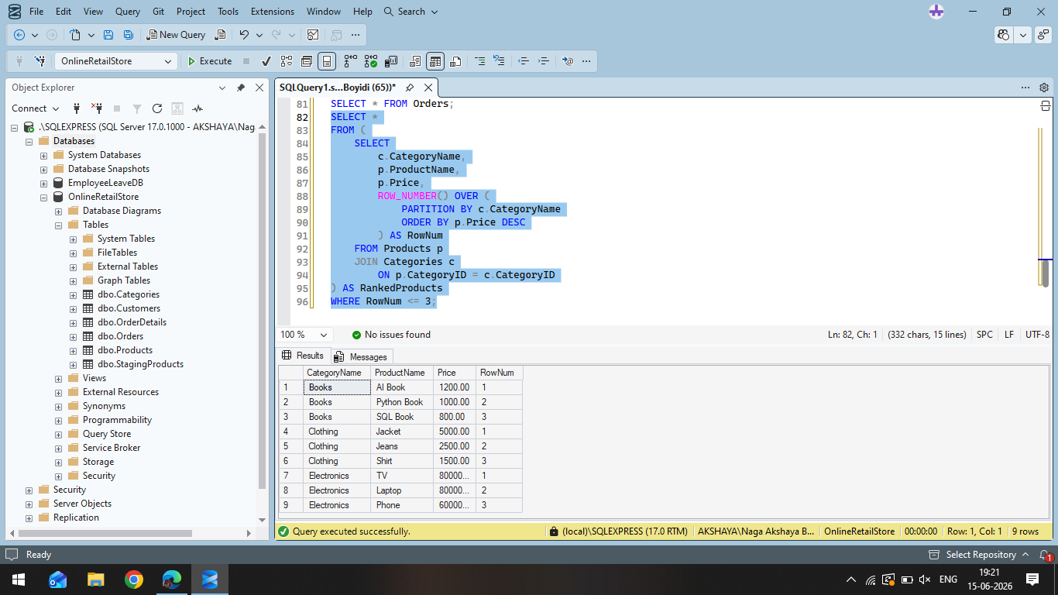

Query 2:
Assigns ranks to products, but skips rank numbers when there are ties.

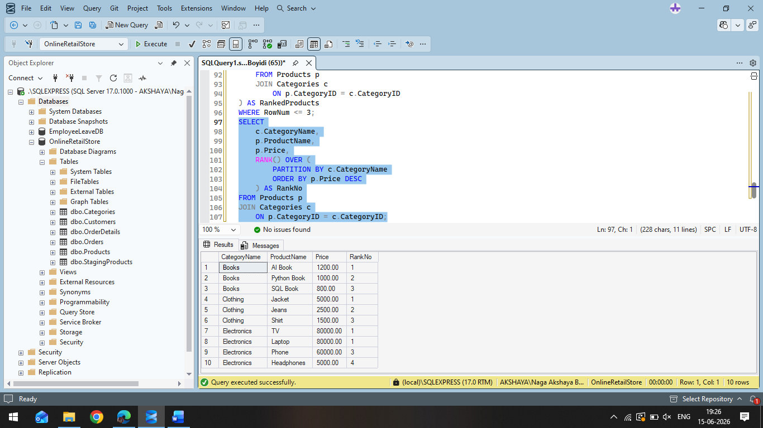
Query-03:
Assigns ranks to products without skipping rank numbers after ties.

